

COM-BLUETOOTH CONNECTOR
User’s Manual

Xinje electronic Co.,Ltd.
NO.PC02 20081016 3.0

Content

1、Introduction - 1 -
1-1. Features - 1 -
1-2. System - 1 -
1-3. Indicator - 1 -
1-4. Installation - 1 -
2、Procedure - 2 -
2-1. Process - 2 -
2-2. Procedure - 2 -
2-3. Timeouts Setting - 8 -

1、Introduction

1-1. Features
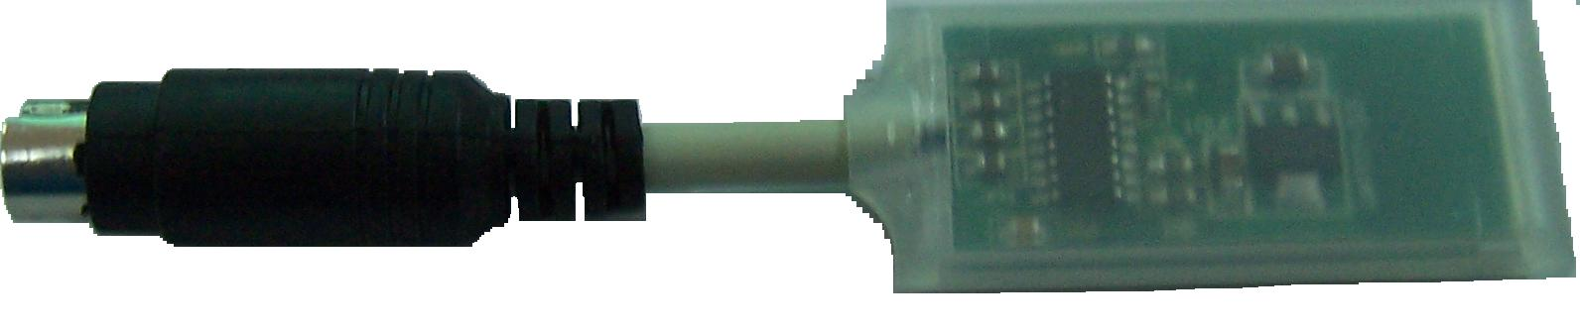
- Based on Bluetooth wireless technology, COM-BLUETOOTH is used to connect wireless network with CMOS chips built in.
- COM-BLUETOOTH connector supports perfect communication between XC series PLCs and PC over shorter ranges instead of traditional cable, including PLC program transmission, data monitoring ,emulator online function of Twin configuration software.
- Effective Transmission Distance of COM-BLUETOOTH is :0.10m~10m, the communication will be effected if there is obstacle in this range ,such as wall.
- Don’t install COM-BLUETOOTH CONNECTERS while PLC is running.

1-2. System
- Version of XCPPro software: V3.2a or above
- Version of PLC hardware: V2.5 or above
- A complete Bluetooth system contains: XC series PLC, PLC edit tool-XCPPro software, COM-BLUETOOTH Connector, PC with Bluetooth built in.
Note: Only Xinje XC series PLC can match with COM-BLUETOOTH Connector.

1-3. Indicator
There is a indicator on COM-BLUETOOTH Connector with following function:
- Always ON: Connect PLC successfully.
- Glimmer: be in waiting status to seek for Bluetooth.

1-4. Installation
Install COM-BLUETOOTH Connecter on COM1 or COM2 port ,is showed as below:
Installation position

2、Procedure

2-1. Process
Download/Upload program or monitor data.
Open edit software XCPPro V3.2a and select right serial port, which means software connect with PLC successfully
Match PC with BTM, which means connect Bluetooth successfully.
Install Bluetooth in correct way and turn on power for PLC
A、preparing for PC
Notebook (with Bluetooth built in)
Desktop + Bluetooth adapter
B、Install Bluetooth drive
C、Ensure Bluetooth will operate correctly

Ensure Bluetooth on destination PC is in good working condition

2-2. Procedure
- Preparing for PC
A. It is no need to use Bluetooth adapter if the destination PC is with Bluetooth built in. otherwise, please buy the suitable adapter.
B. Install Bluetooth drive
C. Ensure Bluetooth will operate correctly

- Install Bluetooth drive
A、In the most cases, there is no need to install drive because Bluetooth adapter can be used directly with system edition of PC at Windows XP SP2 or above
B、Please install drive software into PC based on the steps in disk offered with Bluetooth if the system version is not XP SP2.
C、After insert Bluetooth adapter, the information indicates whether the installation is successful.
Note: the following steps are based on IVT BlueSoleil software.
3、Connect COM-BLUETOOTH with COM PORT of PLCs, and turn on the PLC power, as you see, the indicator flickers.
4、Right-click the Bluetooth icon, and select , as below:
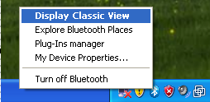
5、Right-click the center button and select ,as below:
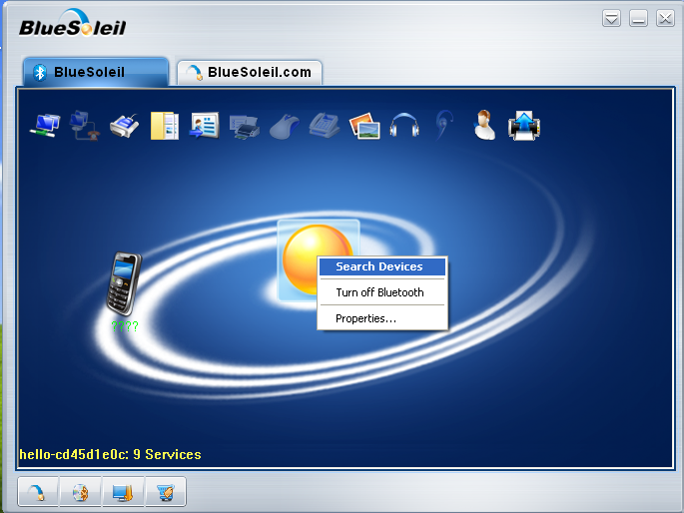
6、In most cases, the Bluetooth is found automatically with the following icon, if not found, please check whether the Bluetooth is installed correctly.

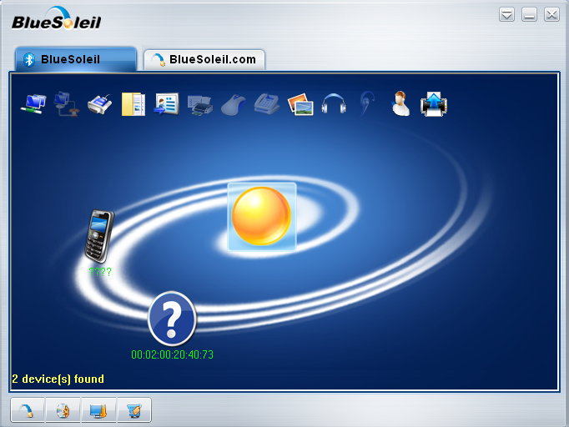
7、Right-click icon and select ‘Pair’, as below:
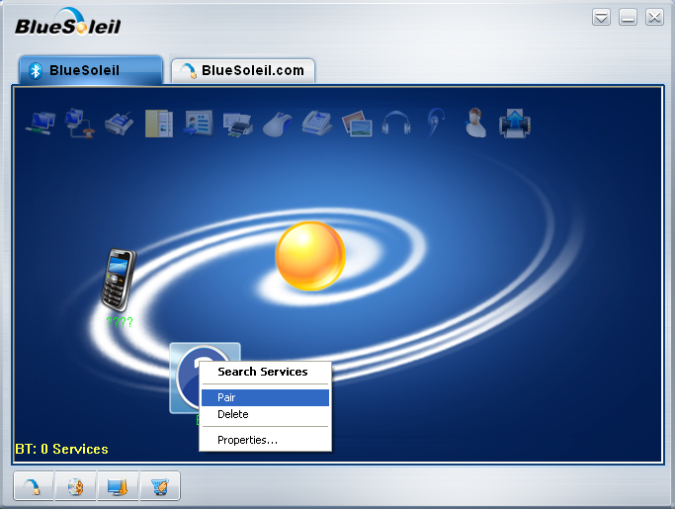
8、Input password ‘0000’in the appeared box.
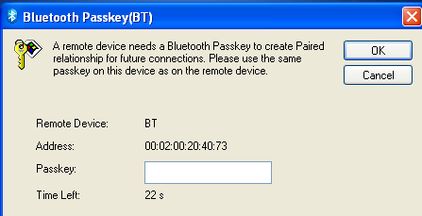
9、Please note the green mark appeared when they paired successfully, as below:
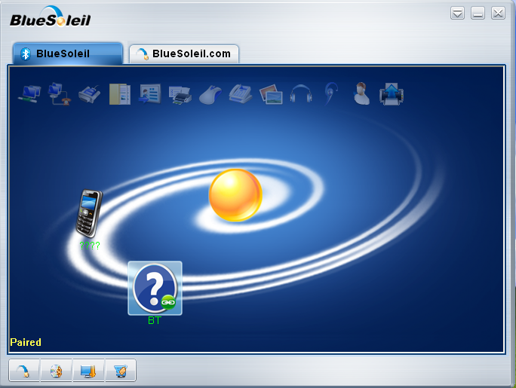
10、Right-click  and select ‘connect Bluetooth Serial Port’
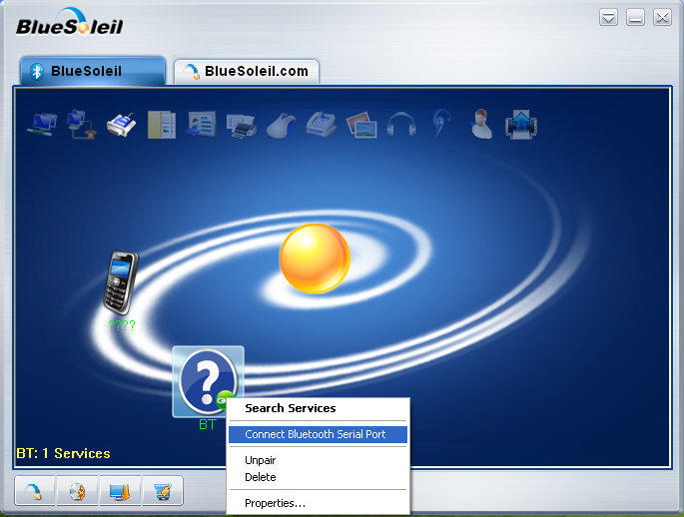
11、The following window appears and please note the COM port ID
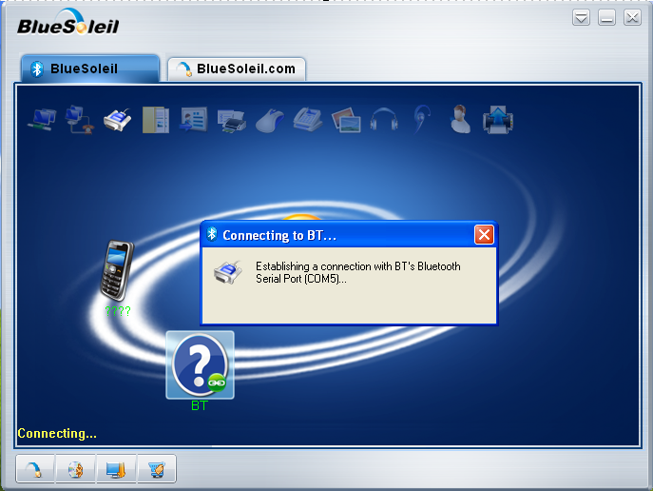
12、The following information appears to indicate successful connection

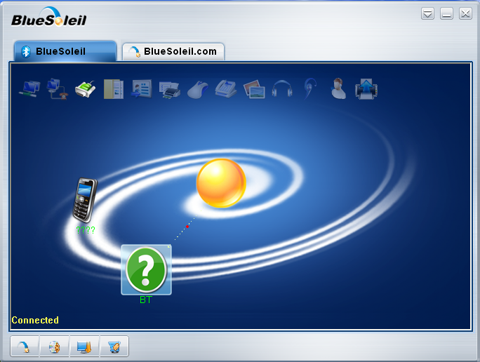
14、Open software XCPPro V3.2b,and select the same COM Port as the above, as below:
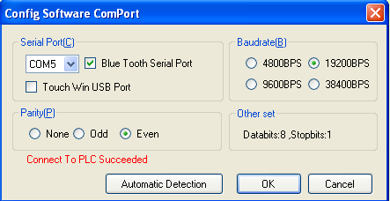
15、Click the ‘Run’button and can monitor the destination datas, as below:
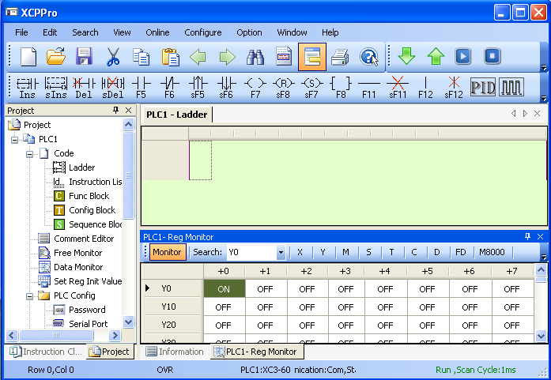
16、After all step is finished,please do operation as usual.

2-3. Timeouts Setting
- Timeouts can be defined by user.
- Find config.ini file from the XCPPro software installation directory, the configuration information is showed as below:
[Comms]
IsComClose=1 // whether the serial port is closed automatically after one communication in normal operation.
1: Automatically close; 0: Do not close.
(Note: Serial port will not be closed automatically if the bluetooth serial port is set.)
IsBlueTooth=1 // 1: Bluetooth serial port, and the following 2 timeouts are taken into account; 0: Normal serial port.
CloseWaitTime=500 // If there is a bluetooth serial port, an additional wait time is added when closing the serial port.
ReadExTime=500 // If there is a bluetooth serial port, the timeout of reading port is add for 300ms.
CharExDiffTime=300 // If there is a bluetooth serial port, the timeout of reading each two characters is add for 300ms.

